Lampiran 1. Lembar Validasi Instrumen Kuesioner I
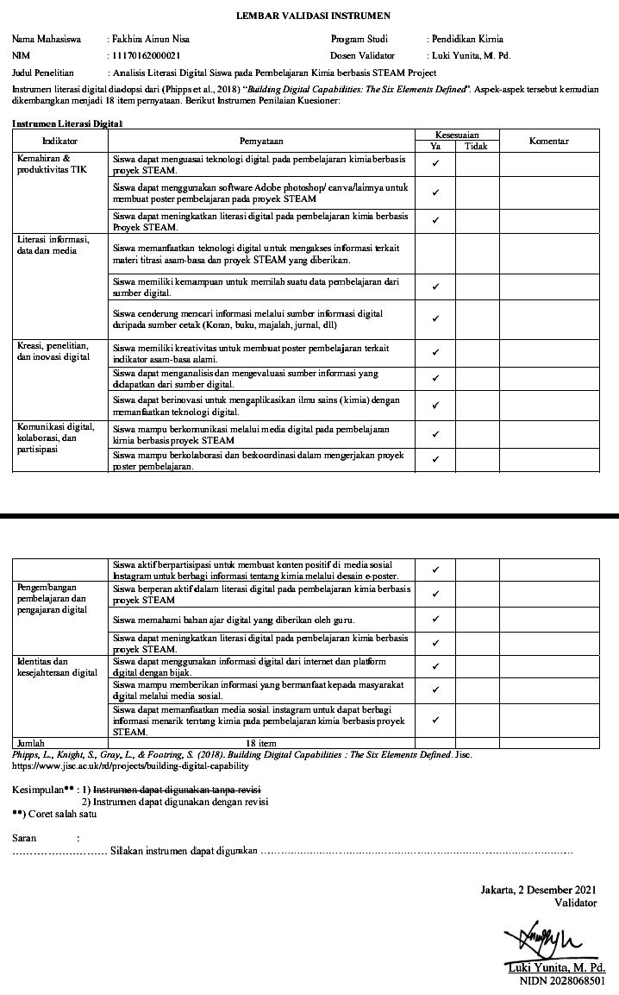
Lampiran 2. Lembar Validasi Instrumen Kuesioner II
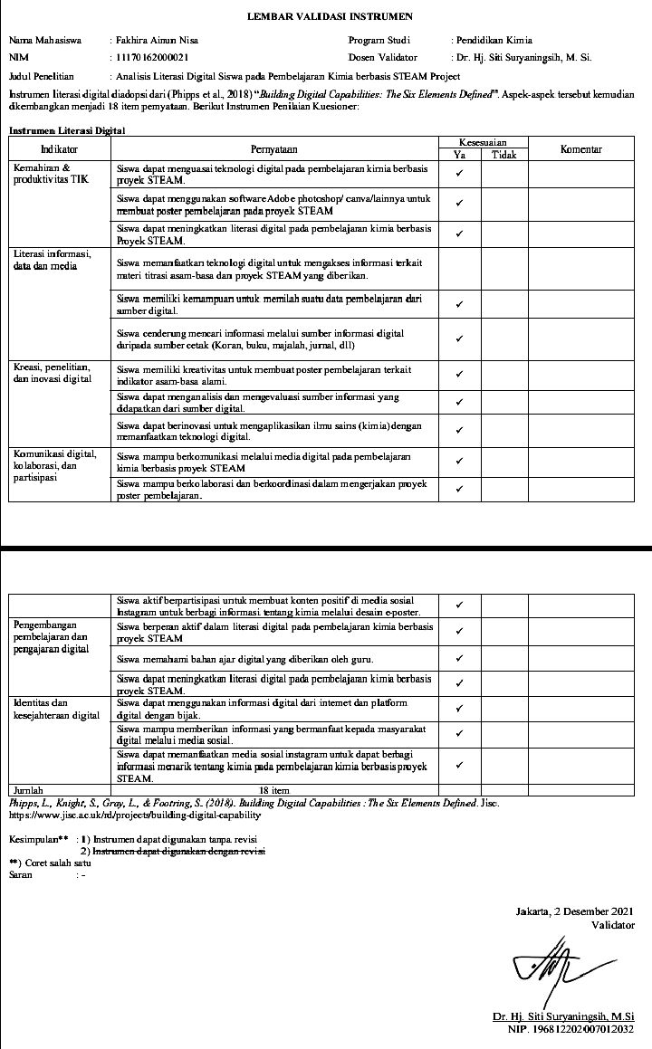
Lampiran 3. Rencana Pelaksanaan Pembelajaran (RPP)
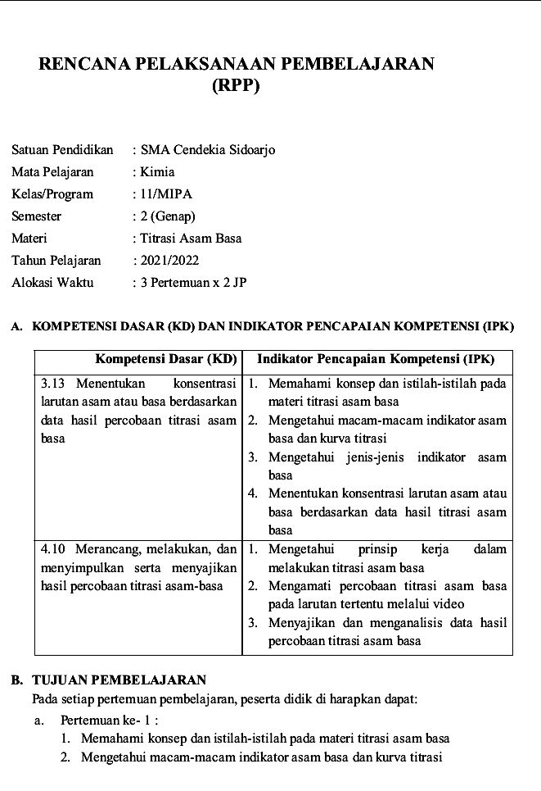

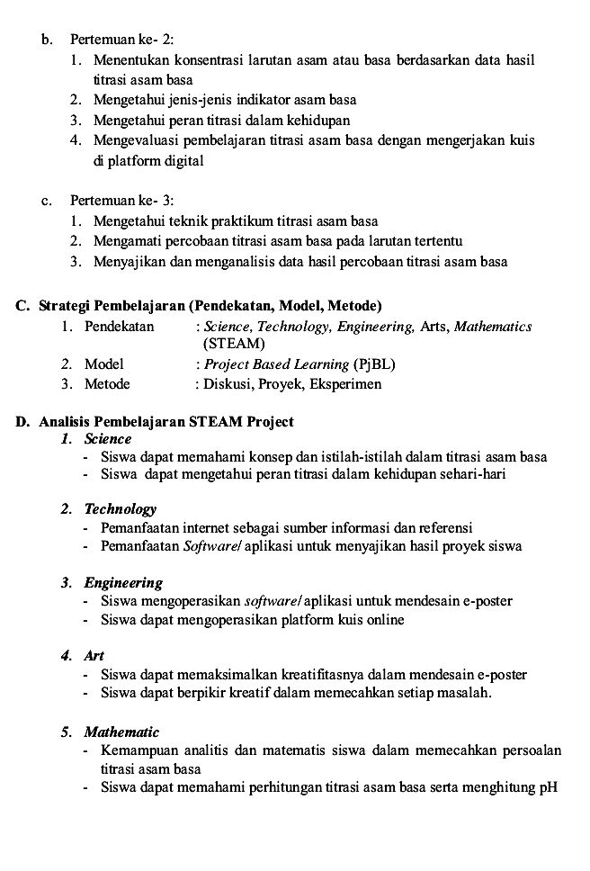

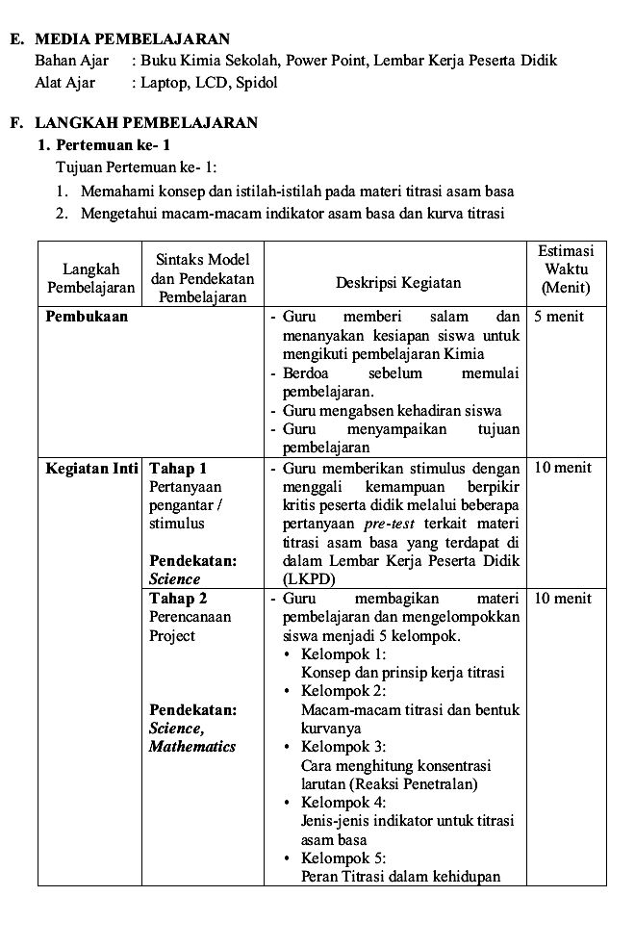

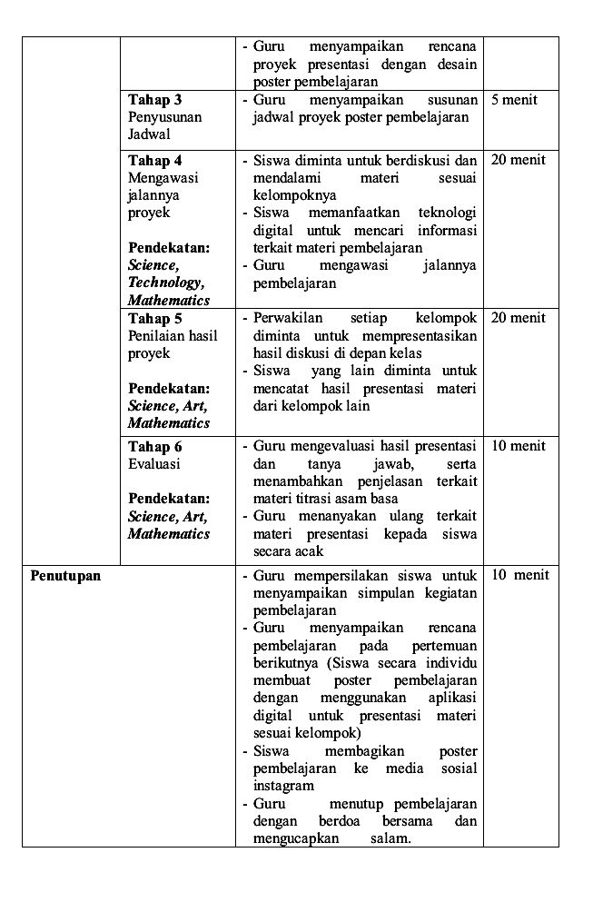

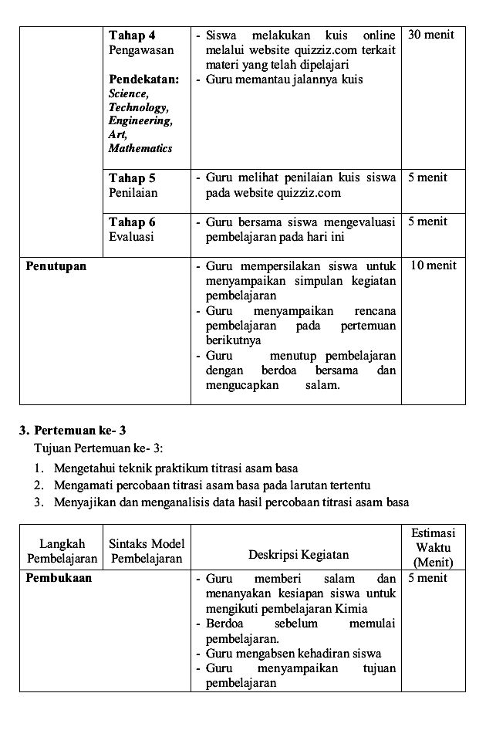
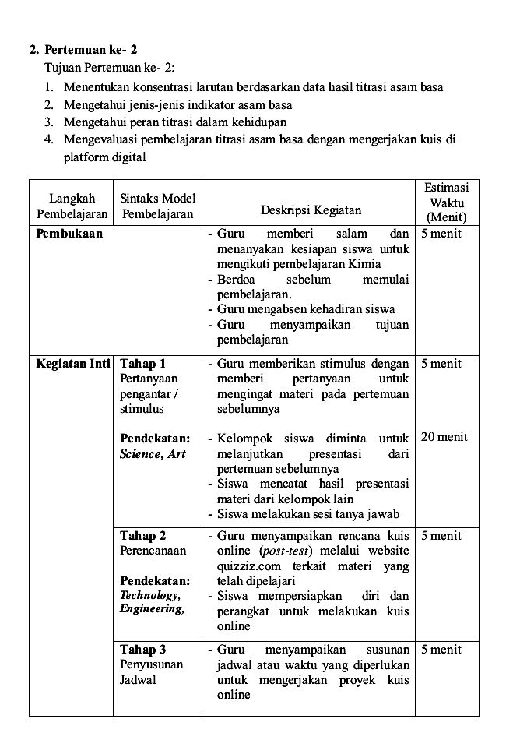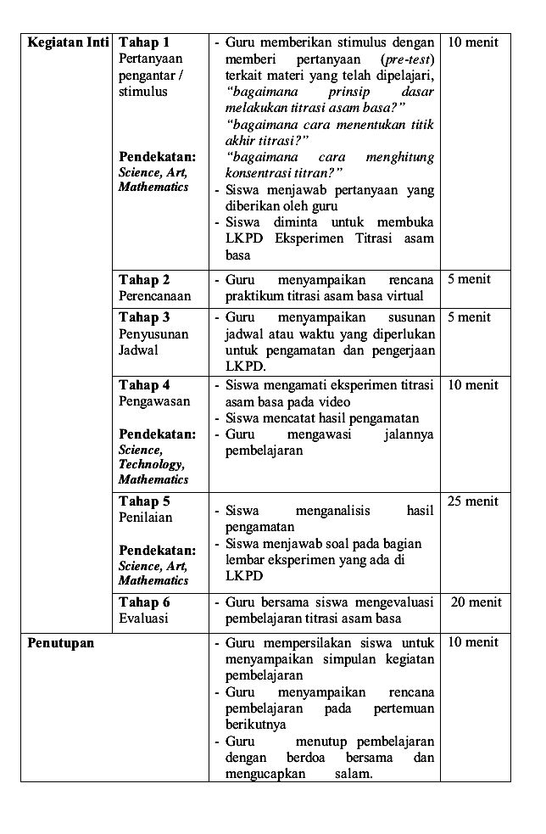

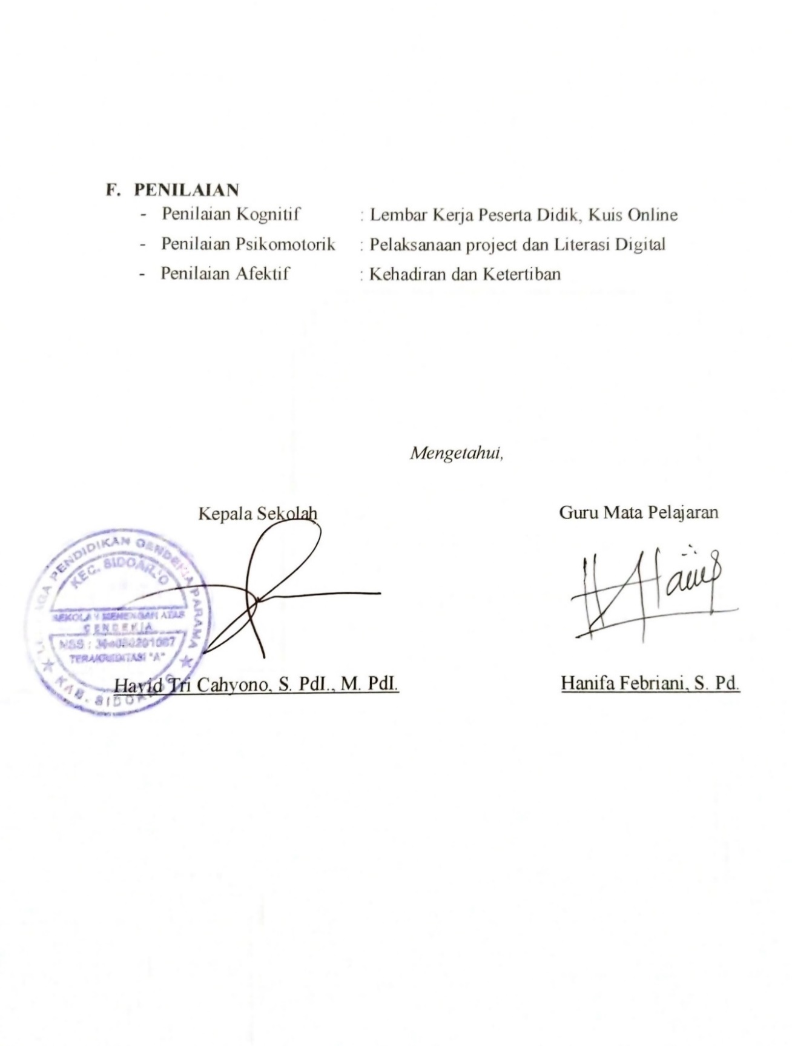
Lampiran 4. Lembar Hasil Uji Validitas dan Reliabilitas Data Empiris

Correlations
 |  | TOTAL
P1 | Pearson Correlation | .768**
P1 | Sig. (2-tailed) | .000
P1 | N | 76
P2 | Pearson Correlation | .670**
P2 | Sig. (2-tailed) | .000
P2 | N | 76
P3 | Pearson Correlation | .658**
P3 | Sig. (2-tailed) | .000
P3 | N | 76
P4 | Pearson Correlation | .692**
P4 | Sig. (2-tailed) | .000
P4 | N | 76
P5 | Pearson Correlation | .619**
P5 | Sig. (2-tailed) | .000
P5 | N | 76
P6 | Pearson Correlation | .691**
P6 | Sig. (2-tailed) | .000
P6 | N | 76
P7 | Pearson Correlation | .723**
P7 | Sig. (2-tailed) | .000
P7 | N | 76
P8 | Pearson Correlation | .562**
P8 | Sig. (2-tailed) | .000
P8 | N | 76
P9 | Pearson Correlation | .667**
P9 | Sig. (2-tailed) | .000
P9 | N | 76
P10 | Pearson Correlation | .749**
P10 | Sig. (2-tailed) | .000
P10 | N | 76
P11 | Pearson Correlation | .633**
P11 | Sig. (2-tailed) | .000
P11 | N | 76
P12 | Pearson Correlation | .682**
P12 | Sig. (2-tailed) | .000
P12 | N | 76
P13 | Pearson Correlation | .707**
P13 | Sig. (2-tailed) | .000
P13 | N | 76
P14 | Pearson Correlation | .550**
P14 | Sig. (2-tailed) | .000
P14 | N | 76
P15 | Pearson Correlation | .559**
P15 | Sig. (2-tailed) | .000
P15 | N | 76
P16 | Pearson Correlation | .482**
P16 | Sig. (2-tailed) | .000
P16 | N | 76
P17 | Pearson Correlation | .632**
P17 | Sig. (2-tailed) | .000
P17 | N | 76
P18 | Pearson Correlation | .632**
P18 | Sig. (2-tailed) | .000
P18 | N | 76
TOTAL | Pearson Correlation | 1
TOTAL | Sig. (2-tailed)
TOTAL | N | 76

**. Correlation is significant at the 0.01 level (2-tailed).
*. Correlation is significant at the 0.05 level (2-tailed).

Uji Reliabilitas
Reliability Statistics
Cronbach's Alpha | N of Items
.917 | 18

Lampiran 5. Data Statistik Deskriptif
Descriptive Statistics
 | N | Minimum | Maximum | Sum | Mean | Std. Deviation
X01 | 30 | 2.00 | 4.00 | 97.00 | 3.2333 | .56832
X02 | 30 | 1.00 | 4.00 | 94.00 | 3.1333 | .57135
X03 | 30 | 2.00 | 4.00 | 99.00 | 3.3000 | .59596
X04 | 30 | 2.00 | 4.00 | 103.00 | 3.4333 | .56832
X05 | 30 | 2.00 | 4.00 | 93.00 | 3.1000 | .80301
X06 | 30 | 2.00 | 4.00 | 91.00 | 3.0333 | .41384
X07 | 30 | 2.00 | 4.00 | 97.00 | 3.2333 | .62606
X08 | 30 | 3.00 | 4.00 | 105.00 | 3.5000 | .50855
X09 | 30 | 3.00 | 4.00 | 99.00 | 3.3000 | .46609
X10 | 30 | 2.00 | 4.00 | 93.00 | 3.1000 | .48066
X11 | 30 | 3.00 | 4.00 | 101.00 | 3.3667 | .49013
X12 | 30 | 2.00 | 4.00 | 97.00 | 3.2333 | .50401
X13 | 30 | 2.00 | 4.00 | 94.00 | 3.1333 | .43417
X14 | 30 | 2.00 | 4.00 | 95.00 | 3.1667 | .59209
X15 | 30 | 3.00 | 4.00 | 102.00 | 3.4000 | .49827
X16 | 30 | 2.00 | 4.00 | 101.00 | 3.3667 | .55605
X17 | 30 | 3.00 | 4.00 | 103.00 | 3.4333 | .50401
X18 | 30 | 3.00 | 4.00 | 103.00 | 3.4333 | .50401
Valid N (listwise) | 30

Lampiran 6. Lampiran pengambilan data kuesioner

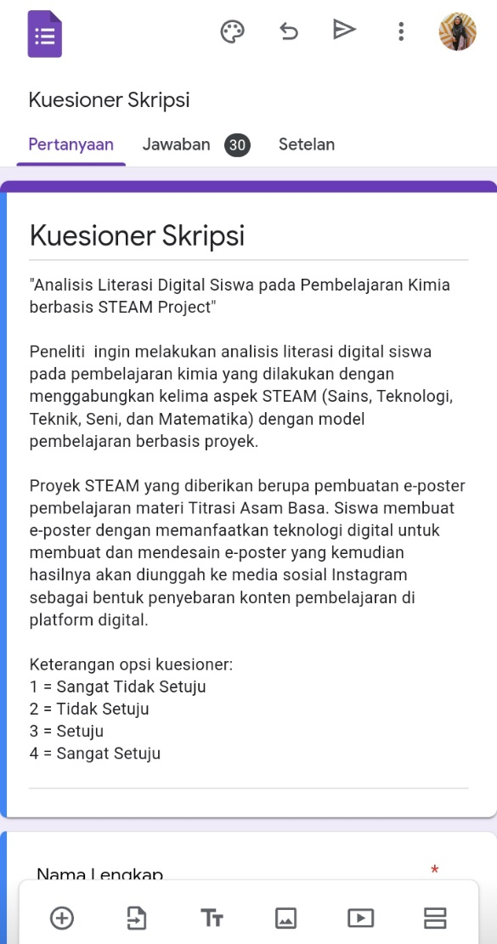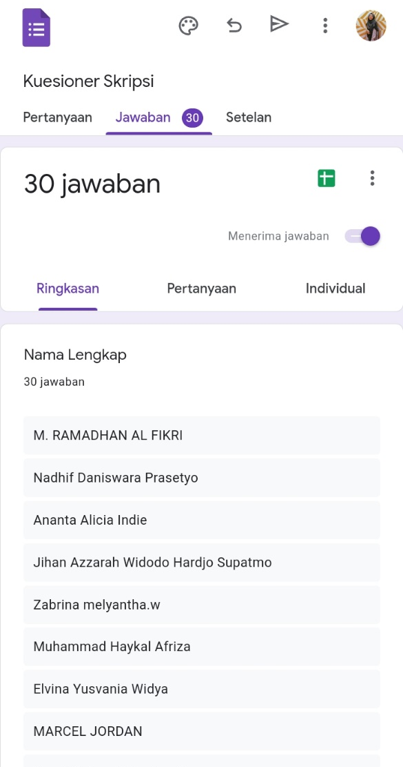

Lampiran 7. Lampiran data kuesioner

No. | Absen | Gender | 1 | 2 | 3 | 4 | 5 | 6 | 7 | 8 | 9 | 10 | 11 | 12 | 13 | 14 | 15 | 16 | 17 | 18
1 | 17 | Laki-laki | 4 | 3 | 4 | 4 | 2 | 4 | 4 | 4 | 4 | 3 | 4 | 4 | 3 | 3 | 3 | 4 | 4 | 4
2 | 19 | Laki-laki | 3 | 3 | 3 | 4 | 4 | 3 | 3 | 3 | 4 | 3 | 4 | 3 | 3 | 4 | 4 | 3 | 3 | 3
3 | 30 | Laki-laki | 3 | 3 | 3 | 3 | 2 | 3 | 3 | 3 | 3 | 3 | 3 | 3 | 3 | 3 | 3 | 3 | 3 | 3
4 | 18 | Laki-laki | 3 | 3 | 3 | 3 | 2 | 3 | 3 | 3 | 3 | 3 | 3 | 3 | 3 | 3 | 3 | 3 | 4 | 3
5 | 22 | Laki-laki | 3 | 3 | 3 | 4 | 4 | 2 | 3 | 4 | 3 | 2 | 3 | 3 | 3 | 4 | 4 | 2 | 4 | 4
6 | 27 | Laki-laki | 2 | 3 | 4 | 3 | 3 | 3 | 3 | 3 | 3 | 3 | 3 | 3 | 3 | 3 | 3 | 4 | 4 | 3
7 | 15 | Laki-laki | 3 | 3 | 3 | 3 | 4 | 3 | 3 | 3 | 3 | 3 | 3 | 3 | 3 | 3 | 3 | 3 | 3 | 3
8 | 11 | Laki-laki | 4 | 3 | 3 | 4 | 4 | 3 | 3 | 3 | 4 | 3 | 3 | 4 | 3 | 3 | 4 | 4 | 3 | 4
9 | 12 | Laki-laki | 3 | 1 | 3 | 2 | 2 | 4 | 4 | 4 | 3 | 3 | 4 | 2 | 3 | 4 | 3 | 4 | 3 | 4
10 | 4 | Laki-laki | 4 | 4 | 4 | 4 | 4 | 4 | 4 | 4 | 4 | 3 | 3 | 3 | 3 | 3 | 4 | 4 | 3 | 3
11 | 8 | Laki-laki | 4 | 4 | 4 | 4 | 4 | 3 | 4 | 4 | 4 | 4 | 4 | 4 | 3 | 4 | 4 | 4 | 4 | 4
12 | 16 | Laki-laki | 3 | 3 | 4 | 4 | 3 | 3 | 3 | 3 | 3 | 4 | 4 | 3 | 2 | 3 | 4 | 4 | 3 | 4
13 | 14 | Laki-laki | 4 | 3 | 4 | 4 | 3 | 3 | 4 | 4 | 4 | 4 | 4 | 4 | 4 | 4 | 4 | 4 | 4 | 4
14 | 21 | Laki-laki | 3 | 4 | 3 | 3 | 2 | 3 | 3 | 3 | 3 | 3 | 3 | 3 | 3 | 4 | 4 | 3 | 3 | 3
15 | 28 | Laki-laki | 3 | 3 | 3 | 3 | 3 | 3 | 3 | 3 | 3 | 3 | 3 | 3 | 3 | 3 | 3 | 3 | 3 | 3
16 | 3 | Perempuan | 4 | 3 | 4 | 4 | 3 | 3 | 3 | 4 | 3 | 3 | 4 | 3 | 4 | 3 | 3 | 4 | 4 | 4
17 | 13 | Perempuan | 3 | 3 | 3 | 3 | 3 | 3 | 3 | 3 | 3 | 3 | 3 | 3 | 3 | 3 | 3 | 3 | 3 | 3
18 | 29 | Perempuan | 3 | 3 | 3 | 3 | 3 | 3 | 3 | 3 | 3 | 3 | 3 | 3 | 3 | 3 | 3 | 3 | 4 | 3
19 | 7 | Perempuan | 3 | 3 | 3 | 3 | 3 | 3 | 3 | 3 | 3 | 3 | 3 | 3 | 3 | 3 | 3 | 3 | 3 | 3
20 | 9 | Perempuan | 3 | 3 | 4 | 4 | 4 | 2 | 4 | 4 | 4 | 4 | 4 | 4 | 4 | 3 | 4 | 3 | 3 | 4
21 | 6 | Perempuan | 4 | 4 | 4 | 4 | 4 | 3 | 4 | 4 | 4 | 3 | 4 | 4 | 4 | 4 | 4 | 4 | 4 | 4
22 | 25 | Perempuan | 3 | 3 | 4 | 4 | 4 | 3 | 2 | 4 | 3 | 3 | 3 | 4 | 3 | 2 | 3 | 4 | 4 | 3
23 | 26 | Perempuan | 3 | 3 | 2 | 3 | 2 | 3 | 2 | 4 | 4 | 3 | 4 | 3 | 3 | 2 | 3 | 3 | 4 | 4
24 | 10 | Perempuan | 3 | 4 | 3 | 4 | 4 | 3 | 4 | 4 | 3 | 3 | 3 | 4 | 3 | 3 | 4 | 3 | 4 | 4
25 | 2 | Perempuan | 3 | 3 | 3 | 3 | 4 | 3 | 2 | 4 | 3 | 3 | 3 | 3 | 3 | 2 | 3 | 3 | 3 | 3
26 | 1 | Perempuan | 3 | 3 | 4 | 3 | 3 | 3 | 4 | 4 | 3 | 3 | 3 | 3 | 3 | 3 | 3 | 3 | 3 | 3
27 | 5 | Perempuan | 4 | 4 | 3 | 4 | 3 | 3 | 4 | 4 | 3 | 4 | 4 | 3 | 4 | 4 | 3 | 4 | 4 | 4
28 | 23 | Perempuan | 4 | 3 | 3 | 3 | 2 | 3 | 3 | 3 | 3 | 3 | 3 | 3 | 3 | 3 | 3 | 3 | 3 | 3
29 | 20 | Perempuan | 2 | 3 | 3 | 3 | 2 | 3 | 3 | 3 | 3 | 2 | 3 | 3 | 3 | 3 | 4 | 3 | 3 | 3
30 | 24 | Perempuan | 3 | 3 | 2 | 3 | 3 | 3 | 3 | 3 | 3 | 3 | 3 | 3 | 3 | 3 | 3 | 3 | 3 | 3

